

Practices for Secure Software Report

Table of Contents
Document Revision History 3
Client 3
Instructions 3
Developer 4
1. Algorithm Cipher 4
2. Certificate Generation 4
3. Deploy Cipher 4
4. Secure Communications 4
5. Secondary Testing 4
6. Functional Testing 4
7. Summary 4
8. Industry Standard Best Practices 4

Document Revision History

Version | Date | Author | Comments
1.0 | 10/15/2026 | Noel Torres

Client



Instructions

Submit this completed practices for secure software report. Replace the bracketed text with the relevant information. You must document your process for writing secure communications and refactoring code that complies with software security testing protocols.

- Respond to the steps outlined below and include your findings.
- Respond using your own words. You may also choose to include images or supporting materials. If you include them, make certain to insert them in all the relevant locations in the document.
- Refer to the Project Two Guidelines and Rubric for more detailed instructions about each section of the template.

Developer
Noel Torres

Algorithm Cipher

For Artemis Financial, I would recommend AES-256 as the encryption cipher for protecting sensitive information. AES is a symmetric encryption algorithm, meaning the same secret key is used to encrypt and decrypt the data. The 256 in AES-256 refers to the 256-bit key size, which provides strong protection for sensitive financial information. AES replaced older encryption standards such as DES, which became less secure as computers became more powerful, and AES is still commonly used today.
For data integrity, I used SHA-256 in this project. SHA-256 is part of the SHA-2 family and produces a 256-bit hash value. Unlike encryption, hashing is one-way and can be used to check whether data has been changed. Random number generation is also important when creating cryptographic keys because predictable values can make security easier to attack. Asymmetric encryption uses a public and private key pair instead of one shared key. In this project, I generated a 2048-bit RSA key pair for the self-signed certificate. Using current algorithms such as AES-256, SHA-256, and RSA is more secure than relying on older algorithms such as DES, MD5, and SHA-1.

Certificate Generation
Insert a screenshot below of the CER file.

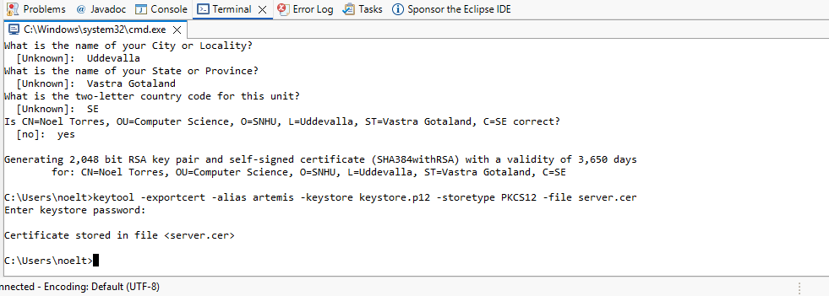

Deploy Cipher
Insert a screenshot below of the checksum verification.

I implemented SHA-256 hashing to generate a checksum for the application. The checksum can be used to verify data integrity because changing the original data would produce a different hash value. I tested the /hash endpoint and confirmed that the application successfully generated the SHA-256 checksum.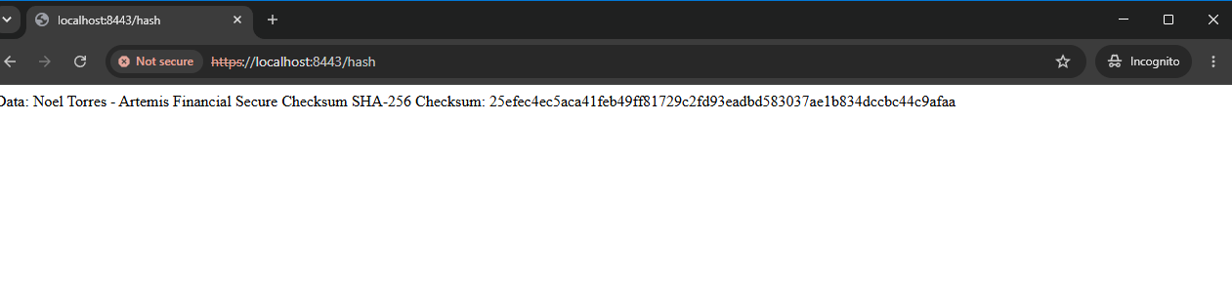

Secure Communications
Insert a screenshot below of the web browser that shows a secure webpage.

I configured the application to use HTTPS on port 8443 instead of an unsecured HTTP connection. HTTPS uses TLS to encrypt information sent between the client and server. I used the self-signed certificate generated for this project to enable the secure connection. The browser warning is expected because the certificate is self-signed and is not issued by a trusted certificate authority

Secondary Testing
Insert screenshots below of the refactored code executed without errors and the dependency-check report.

After making the security changes, I ran OWASP Dependency-Check again to perform secondary testing. This helped identify known vulnerabilities in the application's dependencies and allowed me to check whether the changes introduced any new security issues. The application also executed successfully after the changes were made.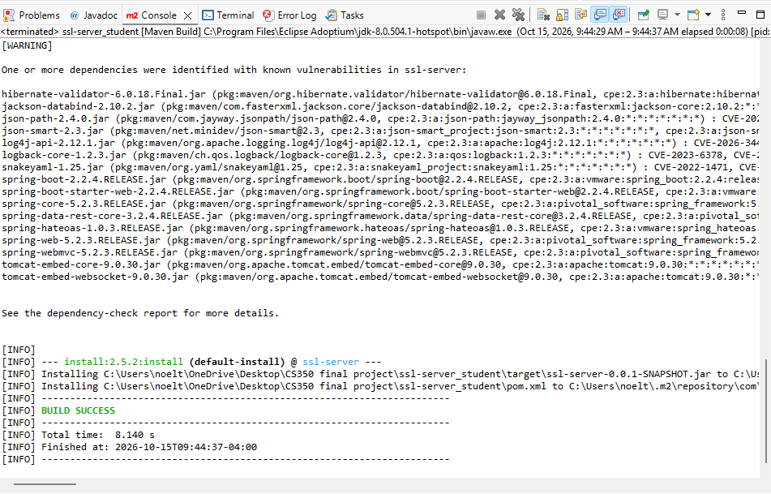

Functional Testing
Insert a screenshot below of the refactored code executed without errors.

I performed functional testing after refactoring the application to make sure the security changes did not prevent it from working correctly. I started the application and confirmed that it ran successfully over HTTPS on port 8443. I also tested the checksum endpoint and confirmed that it continued to generate the expected SHA-256 hash.

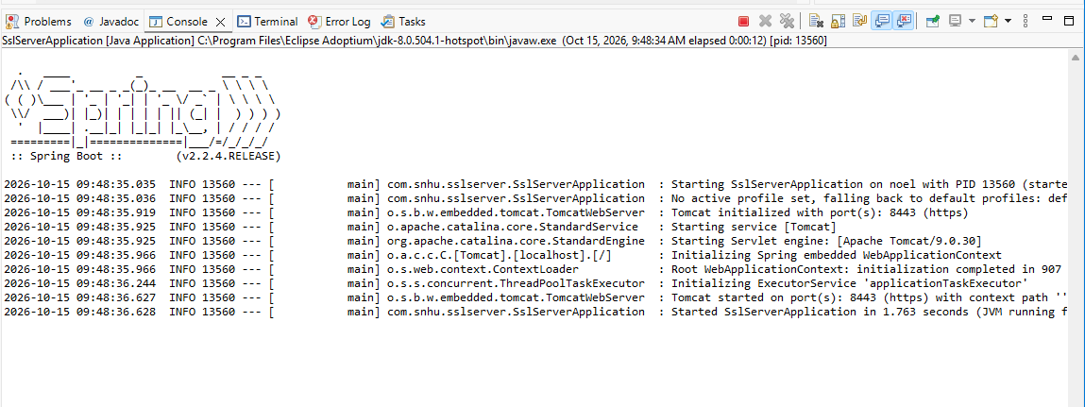

Summary

In this project, I improved the security of the Artemis Financial application by adding HTTPS, generating a self-signed certificate, and creating a SHA-256 checksum to verify data integrity. I also used OWASP Dependency-Check to scan the application for known vulnerabilities. The scan found vulnerabilities in several of the older dependencies used by the project, showing why it is important to keep libraries and frameworks updated. After making the changes, I tested the application and confirmed that it successfully ran over HTTPS on port 8443 and generated the checksum correctly. Overall, these changes helped improve the confidentiality and integrity of the application and showed how security testing can be used throughout the development process.

Industry Standard Best Practices

Some industry standard best practices I used in this project included HTTPS, secure hashing, certificates, and dependency testing. HTTPS helps protect information while it is being sent between the client and server, while SHA-256 can be used to verify that data has not been changed. I also used OWASP Dependency-Check to identify known vulnerabilities in the application's dependencies. Going forward, Artemis Financial should regularly update its dependencies, continue running security scans, use trusted certificates in a production environment, and test the application after security changes are made. Following these practices can help reduce vulnerabilities and keep sensitive financial information more secure.

